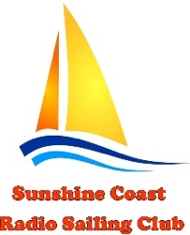

THE BRIGHTWATER HOTEL

AUSTRALIA DAY
REGATTA
Sunday 26 January 2020

Full race program for IOMs and RC Lasers
All races are handicap races.

FREE ENTRY
$500 cash equivalent in prizes

Sponsors Stone and Wood Brewery
Jansz Wines
Brightwater Hotel

Go to https://www.scrsc.org.au to nominate.

Sunshine Coast Radio Sailing Club

