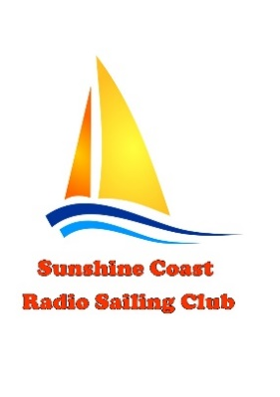
Sunshine Coast Radio Sailing Club

KAWANA OPEN Regatta

Saturday 28th November 2020

ENTRY FORM

FULL NAME ………………………………………………………………………………………………………………..

EMAIL ………………………………………………………………………………………………………………………..

MOBILE NO. ………………………………………………………………………………………………………………

CLUB ………………………………………………………………………………………………………………………….

SAIL NUMBER …………………………………………….

ENTRY FEE $10 (Payable on day of racing)

Completed entry form to be returned to SCRSC Secretary at sunshinecoastrsc@gmail.com

FURTHER INFORMATION
Contact:
Garry McMahon
0431910346

