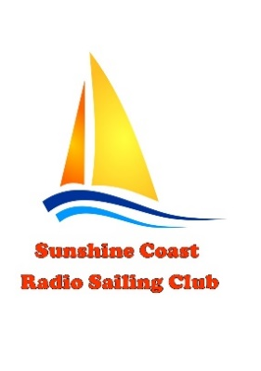
Sunshine Coast Radio Sailing Club Inc.
360 SAILS Coaching/Regatta
Saturday 6th March 2021
Lake Kawana

ENTRY FORM

FULL NAME ………… ……………………………………………………………………………………………………..

EMAIL ………………………………………………………………………………………………………………………..

MOBILE NO. ………………………………………………………………………………………………………………

CLUB ………………………………………………………………………………………………………………………….

BOAT DIVISION: IOM

SAIL NUMBER ……… …………………………………….

PERSONAL NUMBER …………………………………..

ENTRY FEE $15

Completed entry form to be returned to SCRSC Secretary at sunshinecoastrsc@gmail.com

Please refer to the Notice of Race and the Flier on the club’s website

For further information please contact
Derick Warne (Regatta Manager)
0438 563 164
Or
Email: info@dgmarine.com.au

