APPLICATION FOR MEMBERSHIP 2023

I wish to apply for membership of the Sunshine Coast Radio Sailing Club Inc. Please complete the following:

NAME: (please print) ..................................................................................................... DOB: …………………….

ADDRESS: (please print) ……………………………………………………………………………………………………………………………..

Mobile Phone: ……………………………... Email: ....................................................................

Boat Division/s………………………. (IOM, Laser or both)

I am applying for (Please circle the desired membership class). :

FULL ORDINARY MEMBERSHIP
or ASSOCIATE MEMBERSHIP (Family Associate - Type A)
or ASSOCIATE MEMBERSHIP (Member of another club Associate - Type B)
_________________________________________________________________________________________________

Your boat/s information:

- IOM / LASER ( Please Circle ) Boat registered No………………… Sail No.....................

Frequencies (if applicable)…………

Is your boat registered with the ARYA (if applicable)? Yes/ No

Do you hold a current and valid measurement certificate (if applicable)? Yes / No

- IOM / LASER ( Please Circle ) Boat registered No................... Sail No.....................

Frequencies (if applicable).................

Is your boat registered with the ARYA (if applicable)? Yes/ No

Do you hold a current and valid measurement certificate (if applicable)? Yes / No

Are you a current member of another radio sailing club: Yes/ No

Name of Club: ……………………………………………………………………………………………..

Type of Membership ( Please Circle ) : Full Member Associate Member Type A Associate Member Type B

Please Note : Our Membership Year starts 1st December until 30th November each year .

_____________________________________________________________________________________________

I agree to abide by all Club rules and regulations which may be amended from time to time, and participate in such a way as to fulfil the Objects of the club (Rule 2 of Constitution). I understand as a new member applicant, that this application is for Probationary Membership and if it is accepted I will be a Probationary Member until such time as the Committee accepts my application for official membership.

I have read and accept the SCRSC Inc. Code of Conduct (available on SCRSC website) Yes No Please Circle
I have read and accept the SCRSC Inc. Member Protection Policy (as above) Yes No Please Circle

Signed: Date :

Nominated by: ........................................................ Seconded by……………………………………………….…………....
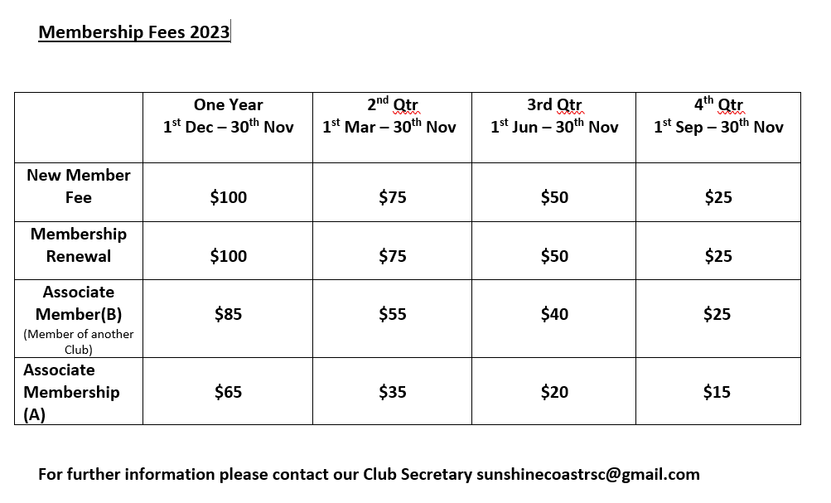
TOTAL AMOUNT PAYING $ ............................................

Please direct deposit your Membership Feee into the club's bank account
Please include your name as a reference for your deposit so we can identify it

E Email your form to SCRSC Secretary sunshinecoastrsc@gmail.com

SUNSHINE COAST RADIO SAILING CLUB Inc. bank account details:

BSB NO. 034-676 (WESTPAC - KAWANA FINANCIAL CENTRE)
ACCT NO: 497593

On receipt of your application our Club Secretary will be in contact with you

